How to access free satellite data? Generalised document.

**1.** Open any of the two links:

<https://scihub.copernicus.eu/dhus/#/home>

<https://earthexplorer.usgs.gov/>

2. Create account and login into the website.

The following steps are demonstrated for Copernicus data (hosted by European Space Agency), website 1 <https://scihub.copernicus.eu/dhus/#/home>

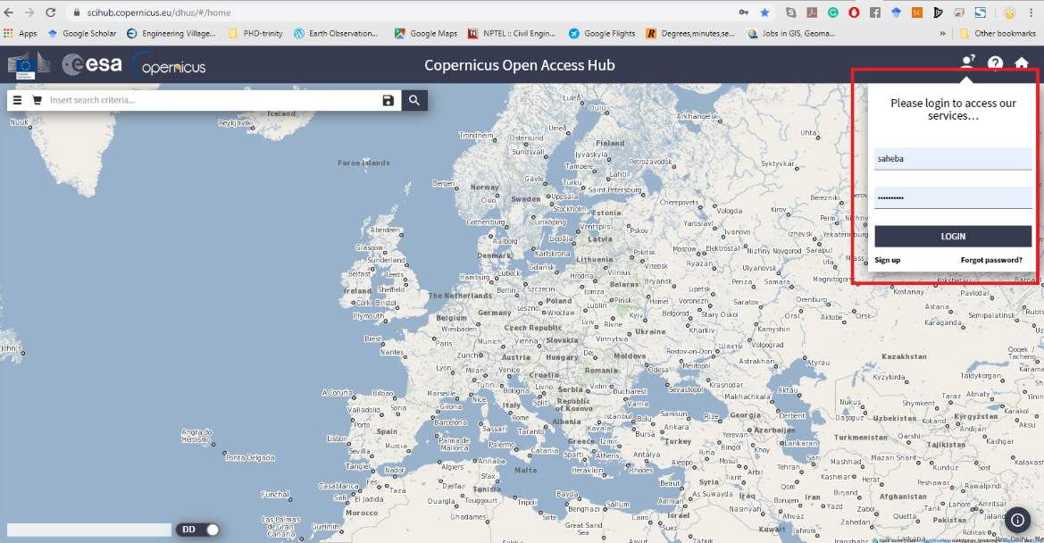

3. Select the area by scrolling and zooming as required.

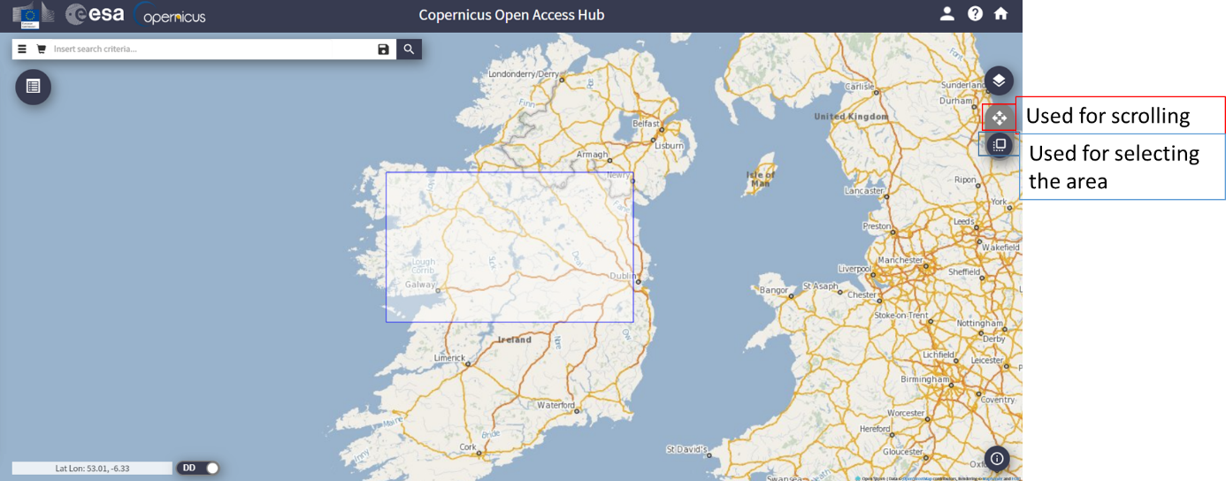

4. Insert search criteria. For optical - coloured images, check *Sentinel-2* products and specify the date for which the image is required.

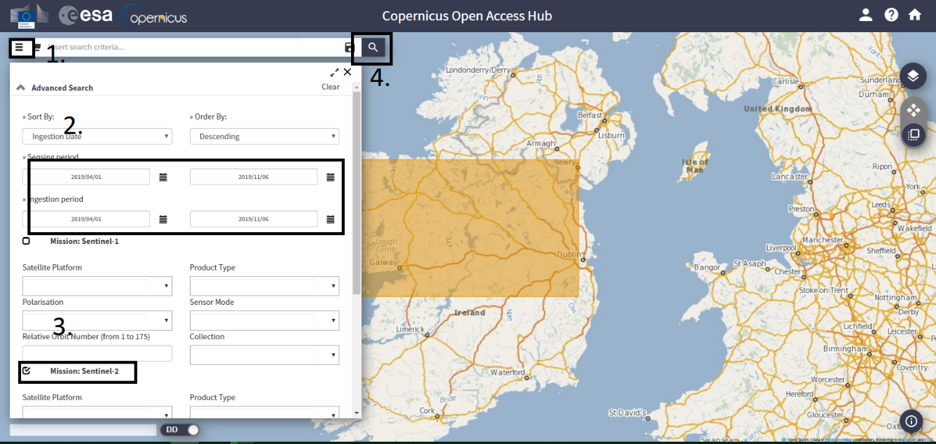

5. Select the image of your choice suiting all the criteria and download.

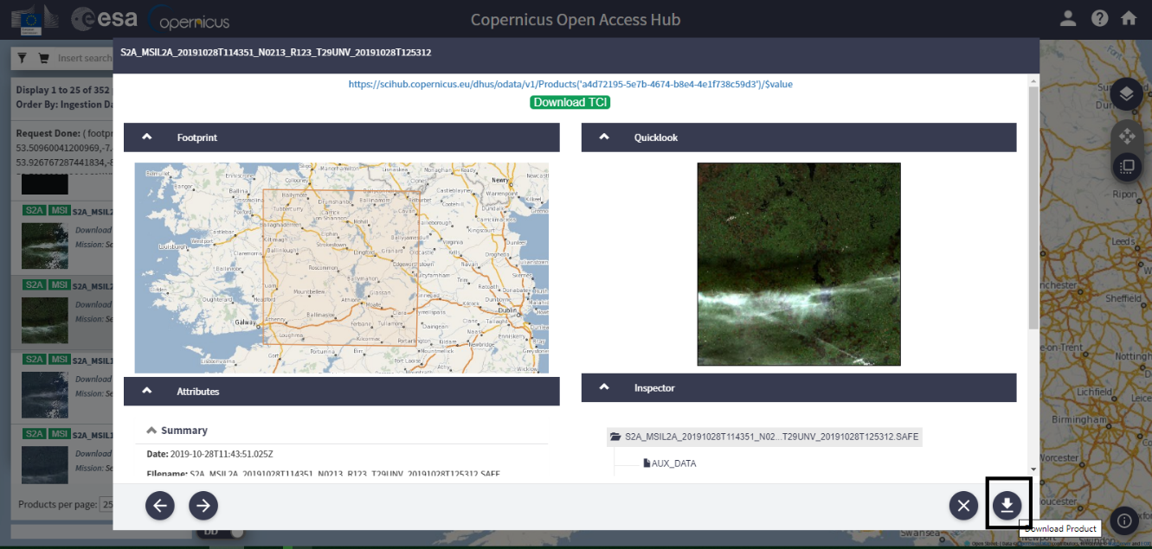

6. To view the file, a software called SNAP is to be downloaded. This software is freely available at <http://step.esa.int/main/download/snap-download/>

7. After installing and launching the SNAP software, open product that is the zip file which was previously downloaded (no need to extract zip file, the software accept the zip file as it is).

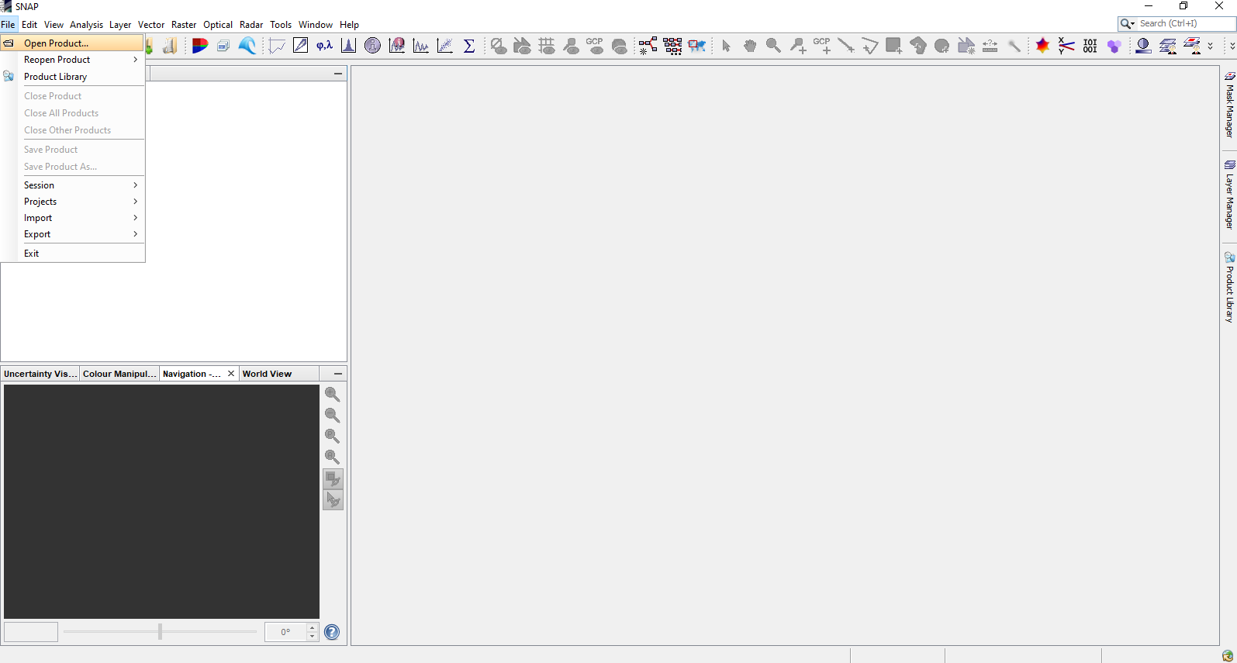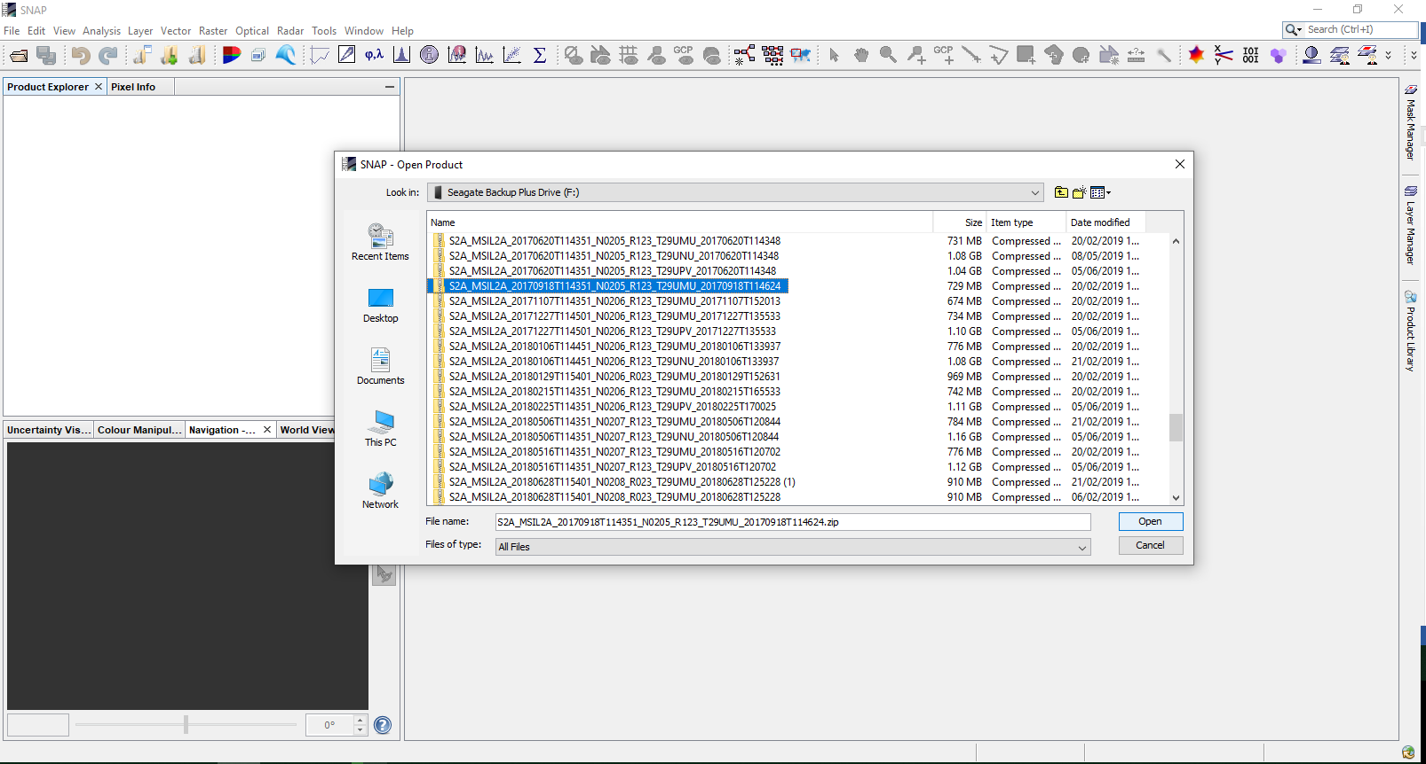

8. Right click on the product and select open as RGB image, click OK for the default band selection. More bands can be viewed using the bands option of the opened product.

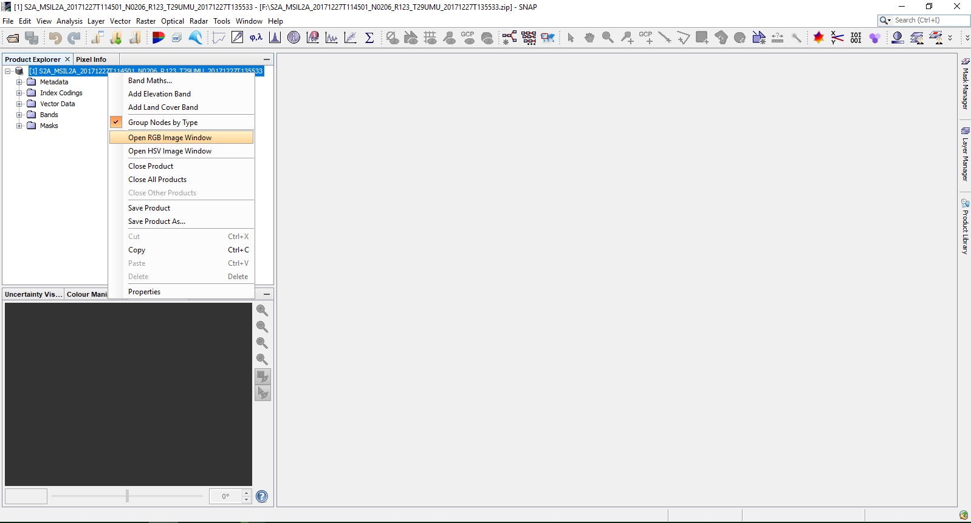

9. The selected band-image can be exported using file🡪export🡪 GEOTIFF/ JPEG (or any desirable format).

---- ----------------------------------------------------------------------------------------------------------- --

For the second website (<https://earthexplorer.usgs.gov/>), the steps are more or less similar till downloading the file. Opening of the file can be done in the similar manner as described in steps 7-9.

Earth explorer is hosted by USGS and data from almost all the available satellites can be viewed here, hence, it is recommended.

Most preferable satellites are Sentinel and Landsat.

STEPS TO BE FOLLOWED AFTER DOWNLOADING THE DATA

1) RESAMPLING

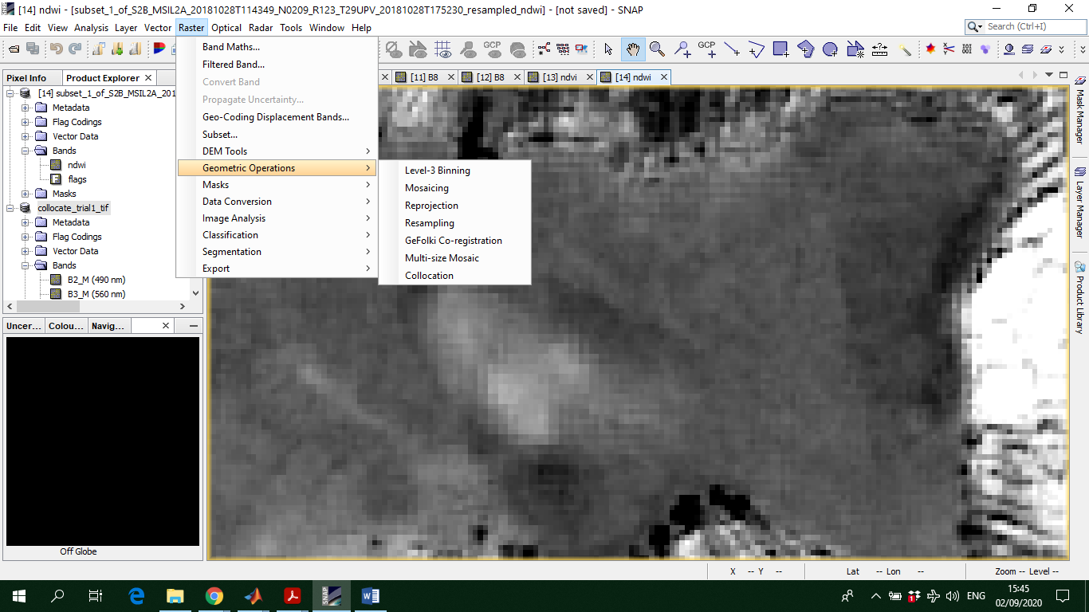SNAP 🡪 Raster 🡪 Geometric operations 🡪 Resampling

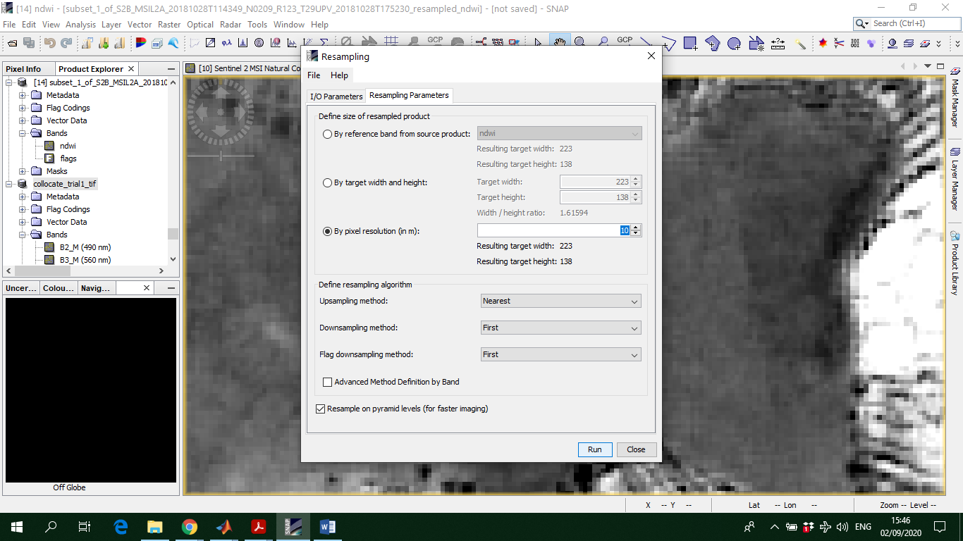In resampling parameters, make sure the correct pixel-resolution is mentioned, in this case 10m.; click run.

2) SUBSET THE AREA OF INTEREST

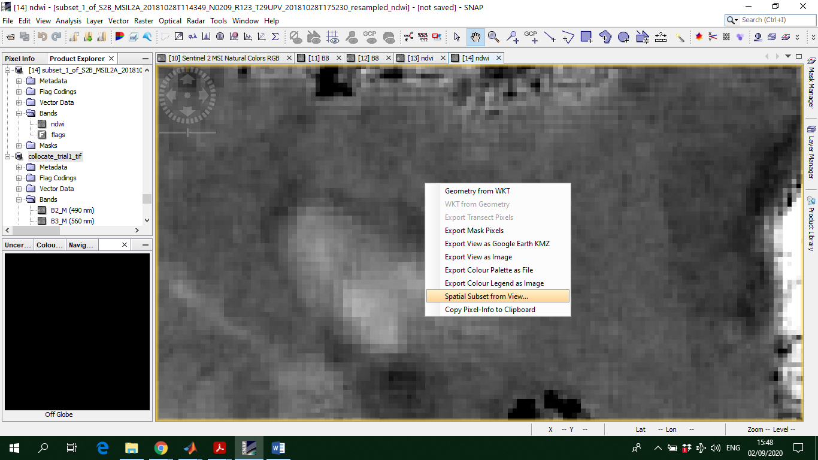Zoom in to the area of interest and right-click, select spatial subset from view

Here you can also select the appropriate bands.

For example, bands for sun zenith angle, etc. are not required for vegetation analysis most of the times. Therefore, it is best to get rid of them.

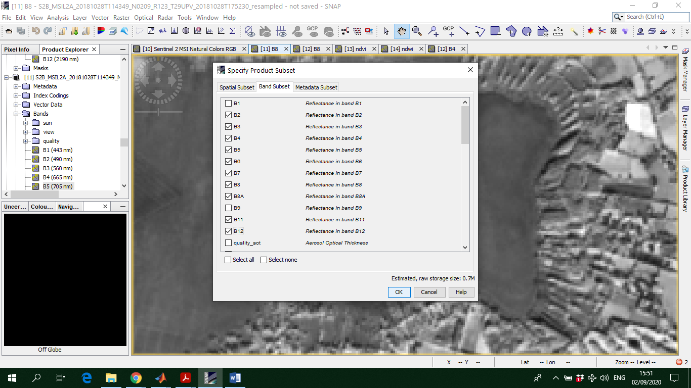Ideal bands: B2, B3, B4, B5, B6, B7, B8, B8A, B11, B12

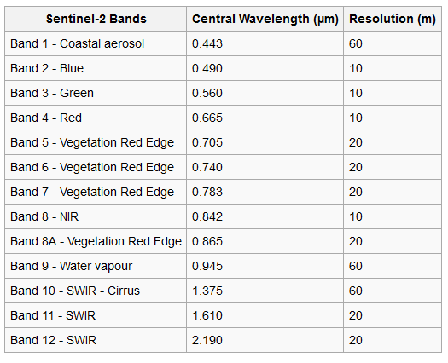

3) GETTING VEGETATION INDICES:

It depends on the wetland, and there is always a certain combination of bands that works better for one wetland, which might be not relevant for others.

But, in general, **NDVI, NDWI, DVI, ARVI, SAVI, PVI** works better.

SNAP 🡪 Optical 🡪 Thematic Land Processing 🡪 Vegetation radiometric indices 🡪 NDVI/ARVI/SAVI…..

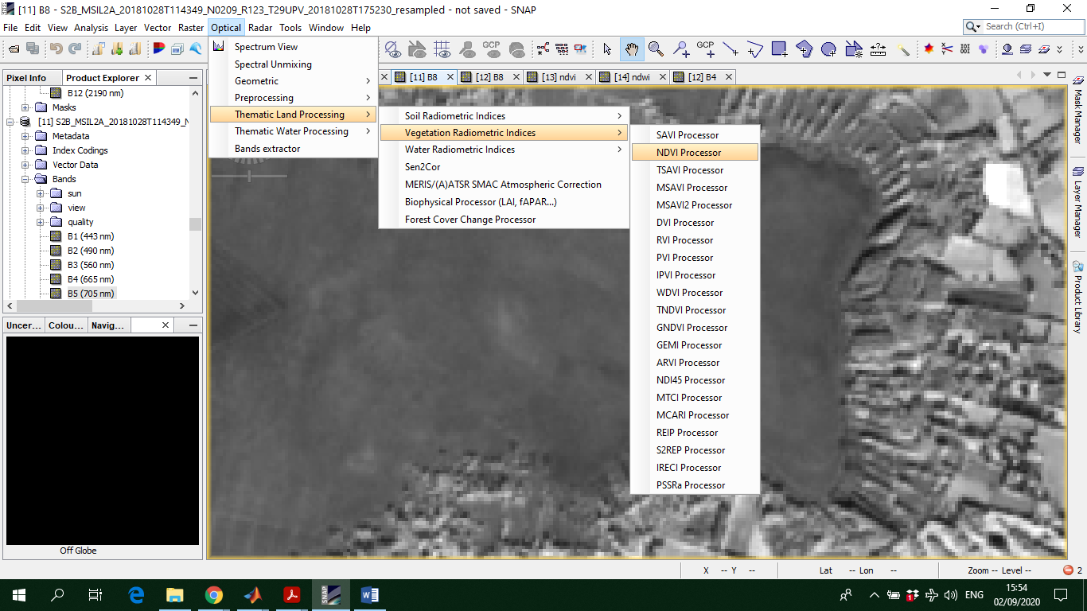SNAP 🡪 Optical 🡪 Thematic Land Processing 🡪 Water Radiometric Indices 🡪 NDWI/NDWI2/…..

4) COLLOCATION

All these bands must be joined together to move from 2-D individual images to a 3-D block of images.

SNAP 🡪Raster 🡪 Geometric Operations 🡪 Collocation

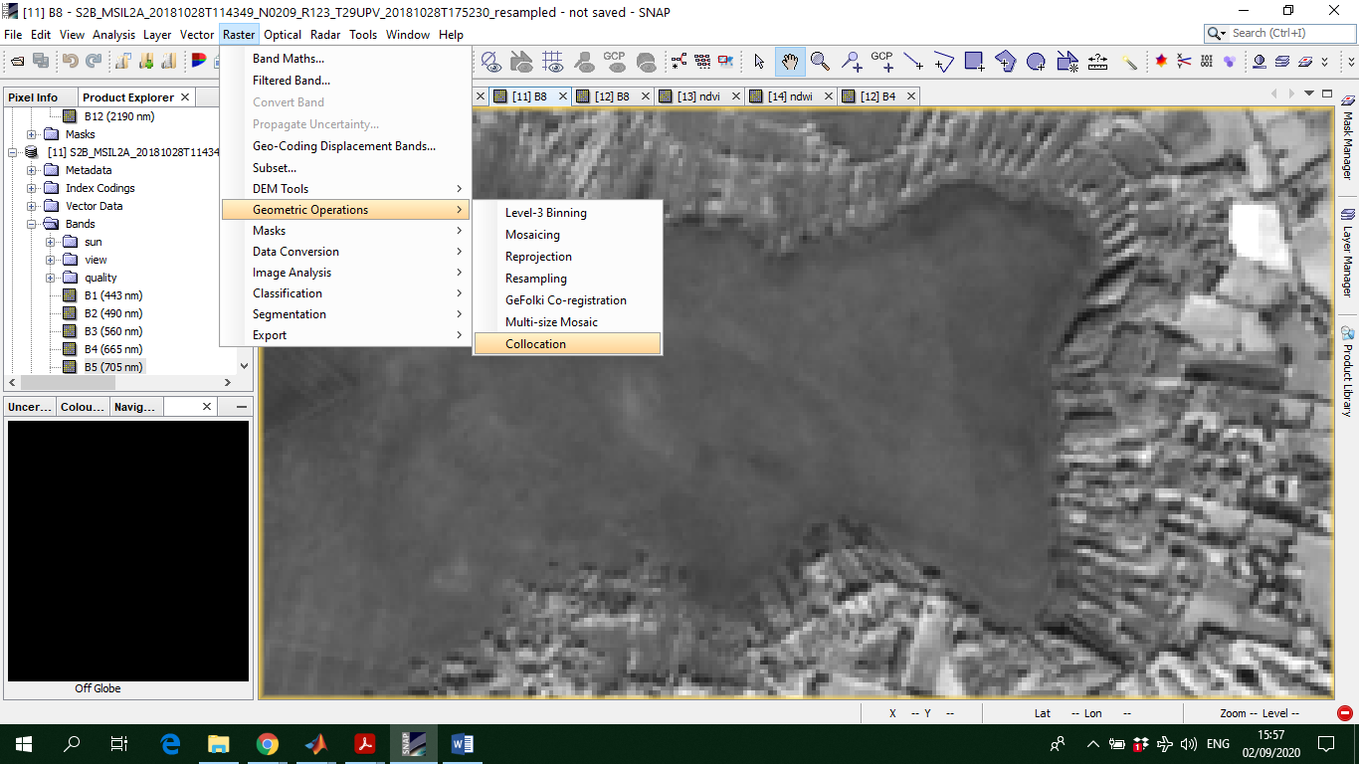Please make sure the actual subset of the image from step 2 is the MASTER product, and the rest of the vegetation indices images are the slave products.

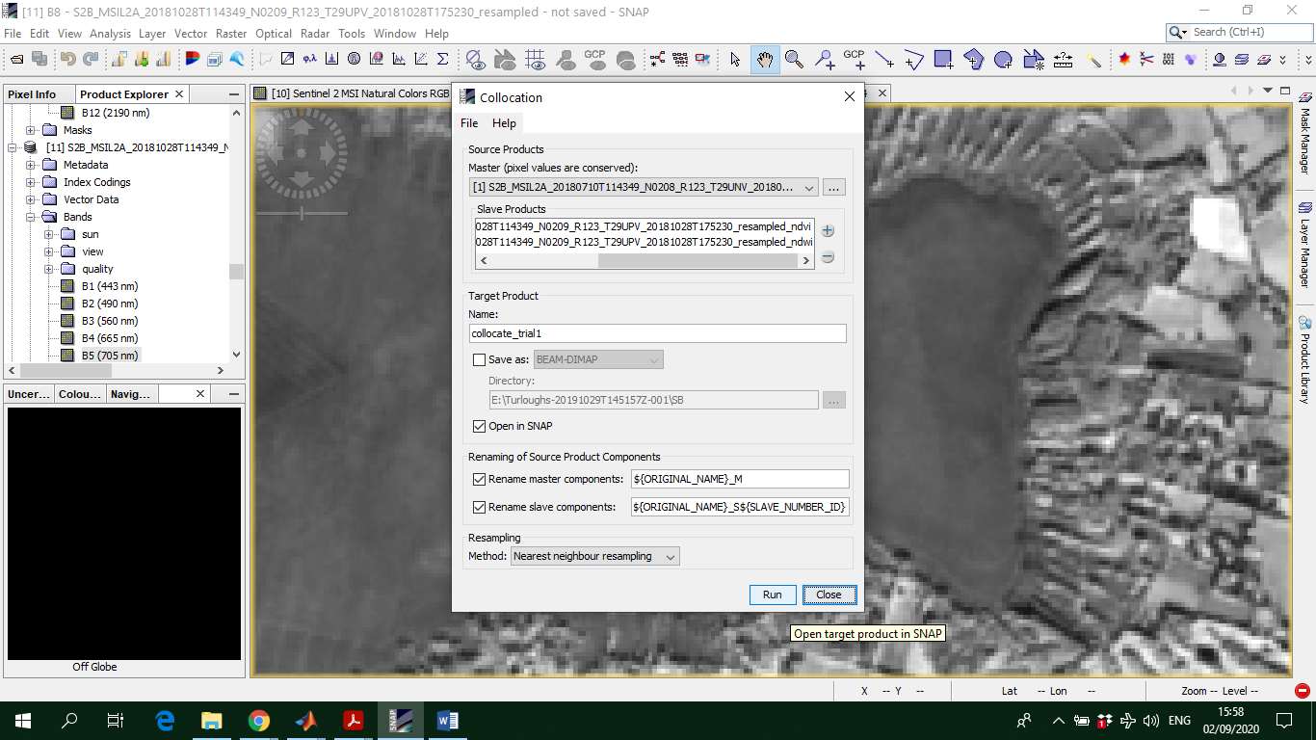5) EXPORT THE FINAL COLLOCATED IMAGE

File 🡪 Export 🡪 Geotiff

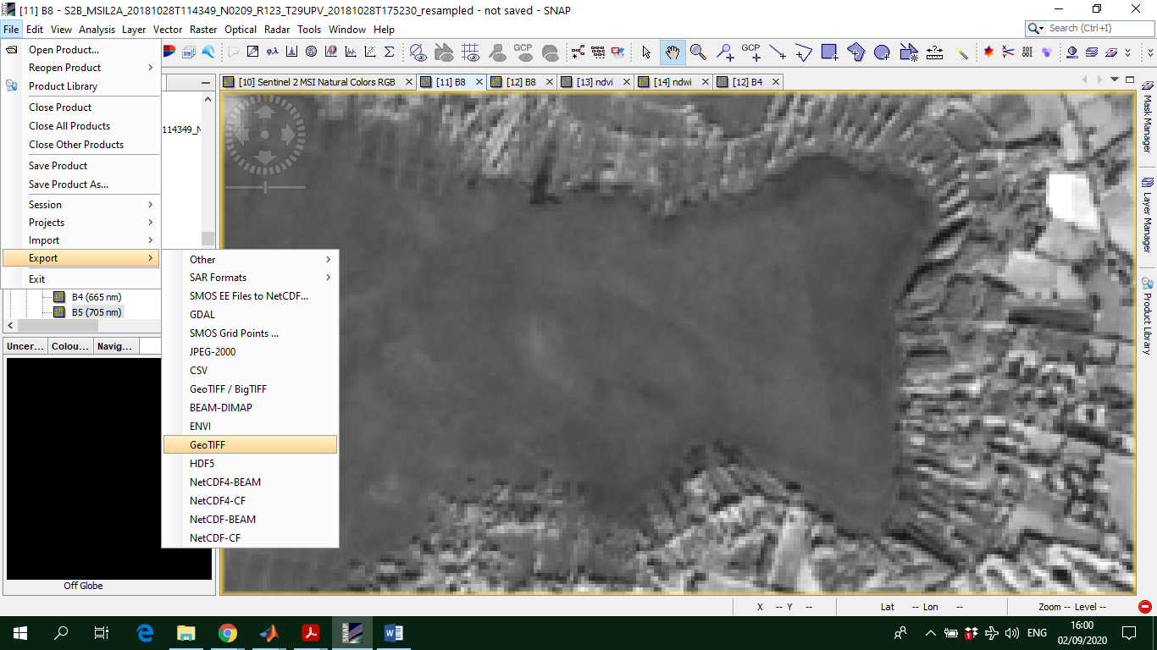

This image is ready to be used directly with the MATLAB code for mapping vegetation.